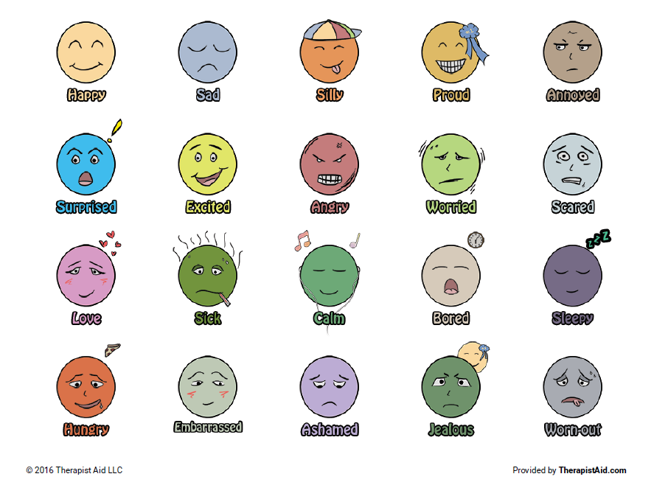

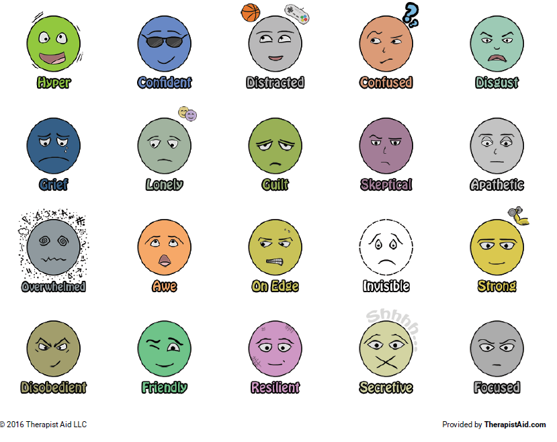

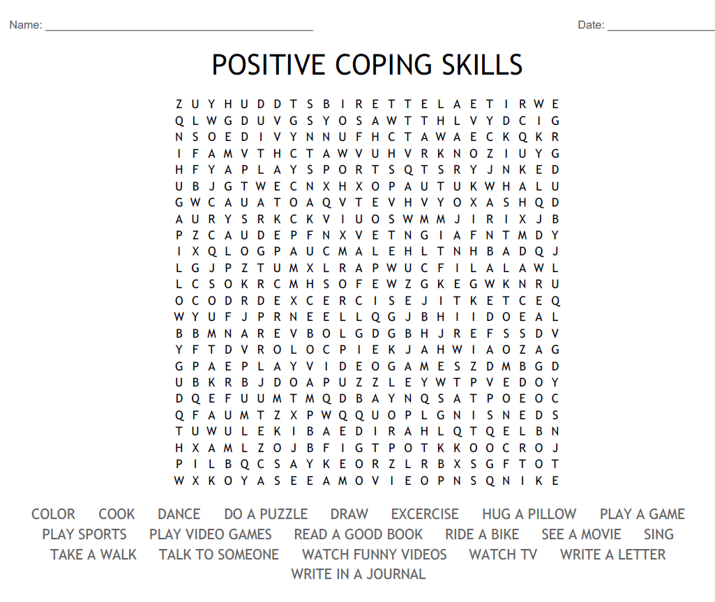

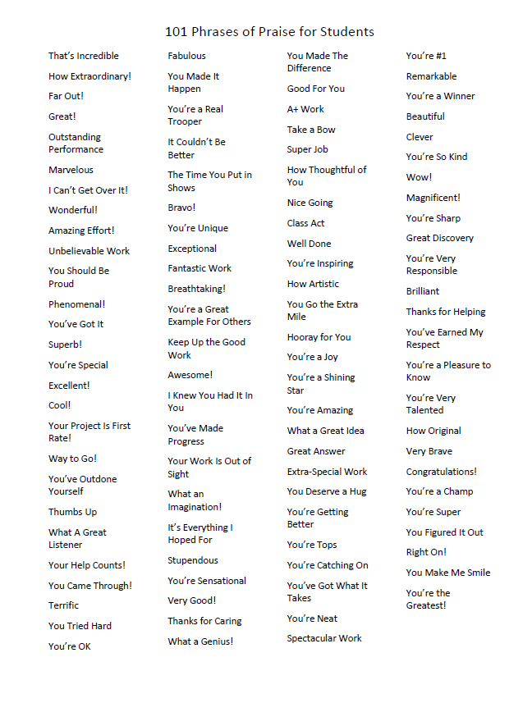

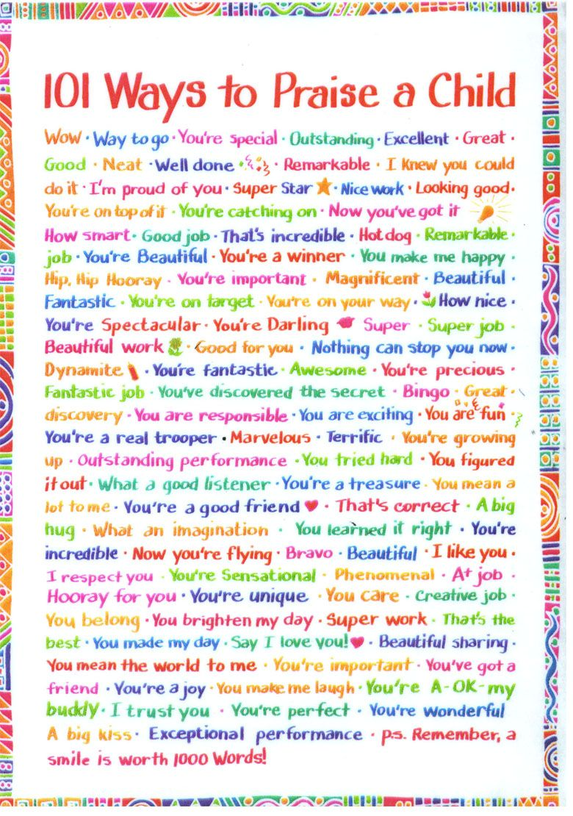

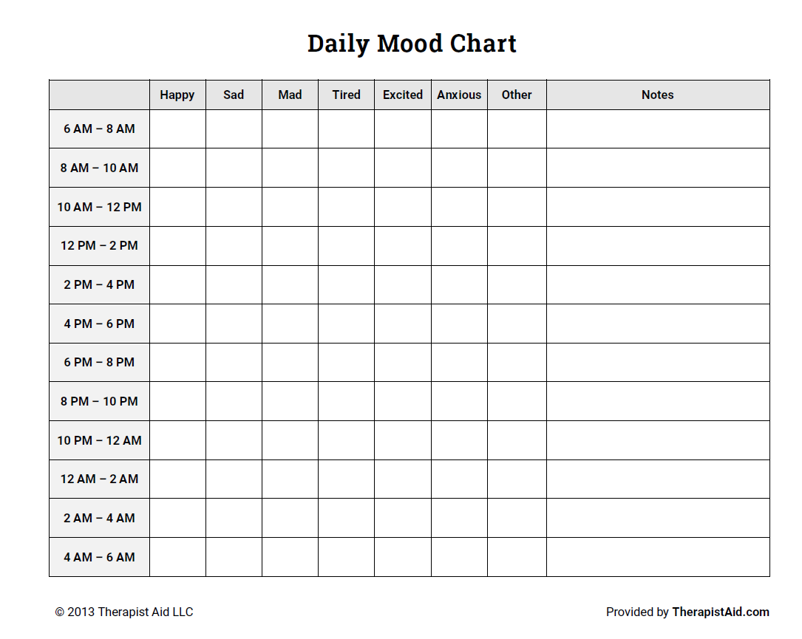

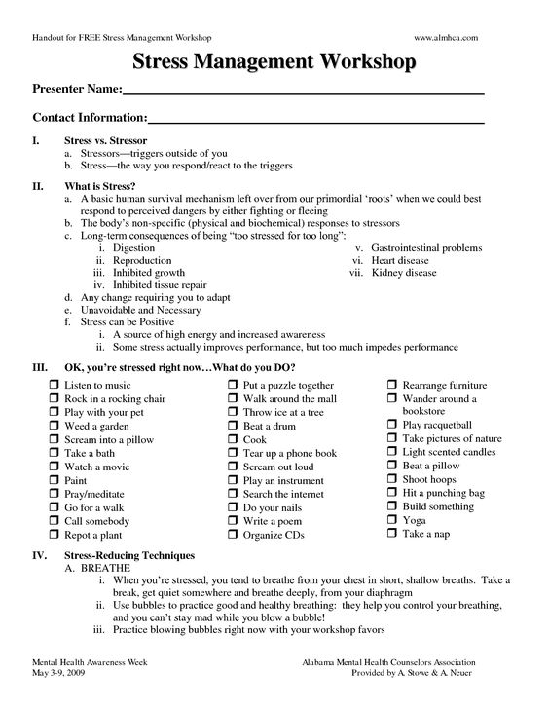

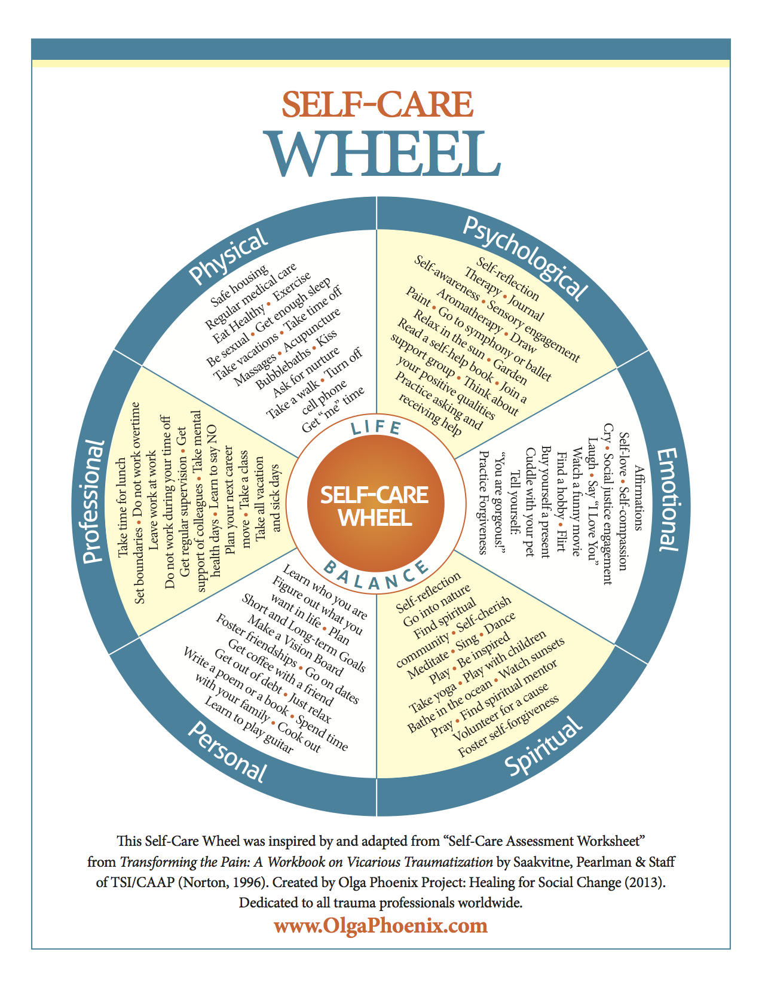

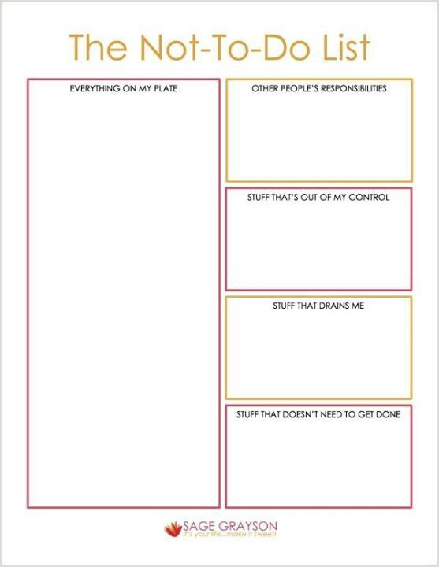
If your needs are urgent or someone is in danger of hurting themselves or others, please call 911 and let them know it is a mental health emergency, go to the emergency room or call a crisis response hotline at a number below:
Anne Arundel County Crisis Response: 410-768-5522
Baltimore City Crisis Response: 410-433-5175
Baltimore County Crisis Response: 410-931-2214
Harford County Crisis Response: 1 (800)-639-8783
Howard County Crisis Response: 410-531-6677
Montgomery County Crisis Response: 240-777-4000
Prince Georges County Crisis Response: 301-429-2185
The Trevor Project (Crisis Intervention and Suicide Prevention Services for LGBTQ+ Community): 866-488-7386

